## Day2:

1. Difference between WHERE and HAVING:
   1. When the query has a GROUP BY clause, WHERE can only be used before GROUP BY, while HAVING can only be used after GROUP BY.
   2. We cannot use HAVING without GROUP BY. However, we can use WHERE without GROUP BY.

Screenshots:

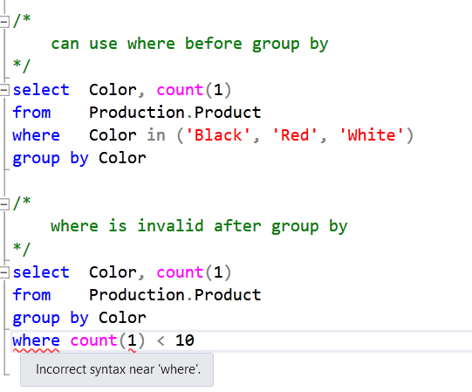

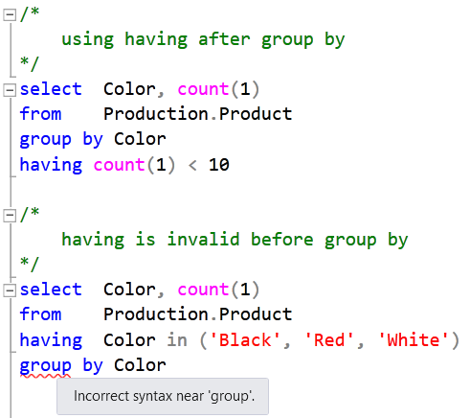

## Day3:

1. CTE benefits
   1. CTE can be used to create a recursive query.
   2. CTE does not store the definition in metadata.
   3. CTE improves readability and manageability of complex SQL statements.
2. CTE vs. View
   1. CTE is the substitute for a View when the general use of a view is not required.
   2. CTE does not store the definition in metadata, while a view stores the definition in metadata.
3. Union vs. Union all
   1. Union will give the unique records but union all will not.
   2. Union will sort the data based on the first column in the first select statement.
   3. Union all is faster.
   4. Union cannot be used inside a recursive CTE.